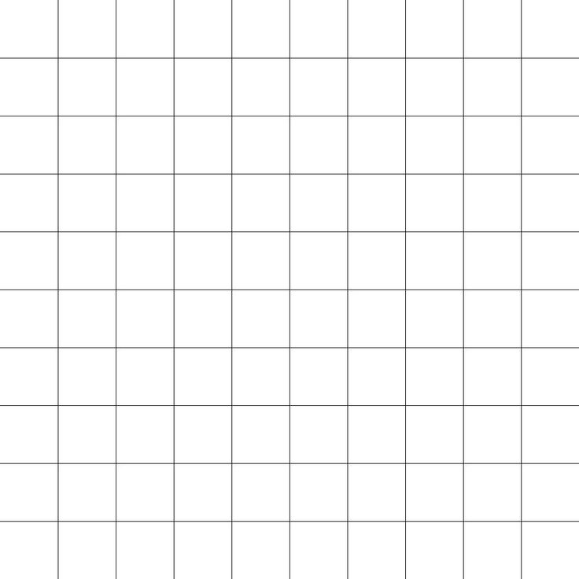

4, 0

3, 0

0, 4

0, 3

Height 10

Width 10

2, 2

1, 2

0, 2

2, 1

1, 1

0, 1

2, 0

1, 0

0, 0

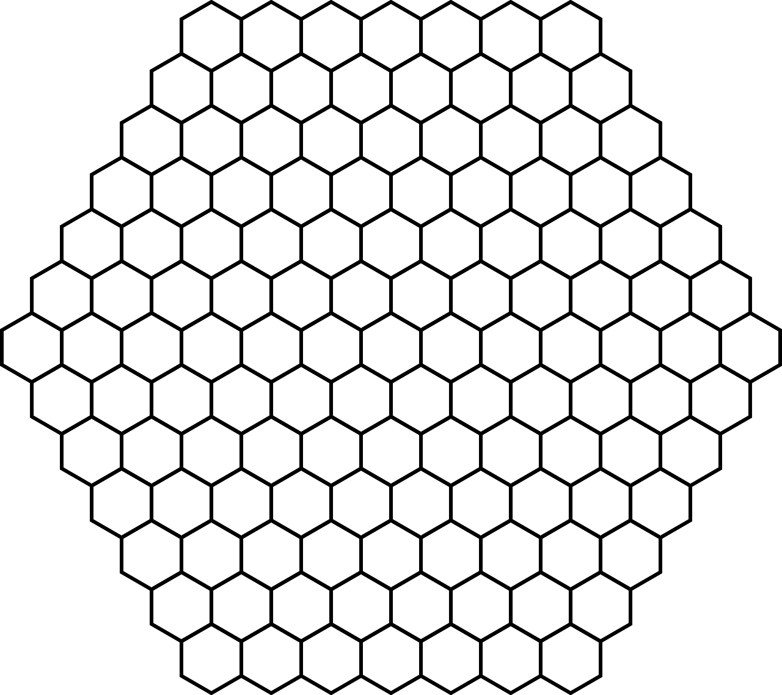

Height 13

(row length increases by 1 each time until halfway, stays the same once if height is even, then decreases by 1 each time)

Width 7

(width controls the length of the first row)

4, 0

3, 0

0, 4

0, 3

2, 2

2, 1

1, 2

1, 1

0, 2

0, 1

2, 0

1, 0

0, 0

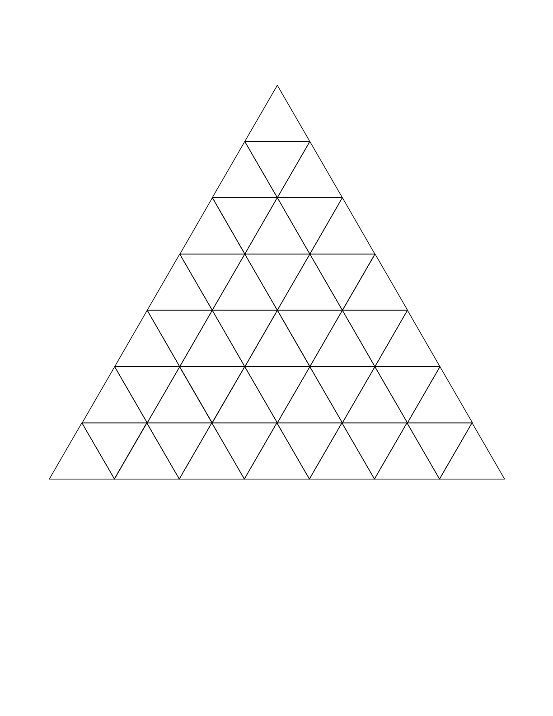

Height 7

(row length increases by 1 each time)

10, 5

0, 5

8, 4

0, 4

Width 1

(width controls the length of the first row)

6, 3

5, 3

4, 3

3, 3

2, 3

1, 3

0, 3

4, 2

3, 2

2, 2

0, 2

1, 2

2, 1

1, 1

0, 1

0, 0